Nama : Nuraida Naelia Masfufah

NIM : 12030123104219

Kelas : C

Mata kuliah : Analisis dan Desain Sistem

Kasus : Case in Point 5.2: Rock Solid Outfitters (Part 1)

1. DFD
2. DFD Level 0

Mermaid Draw.io

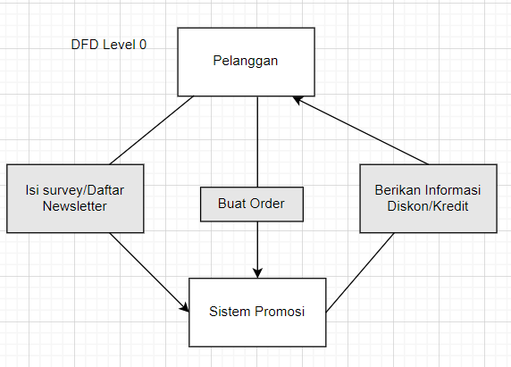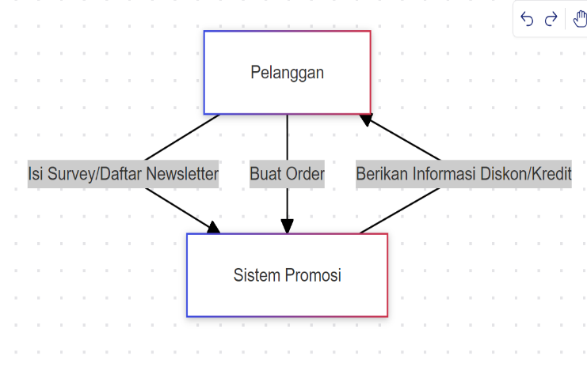

1. DFD Level 1

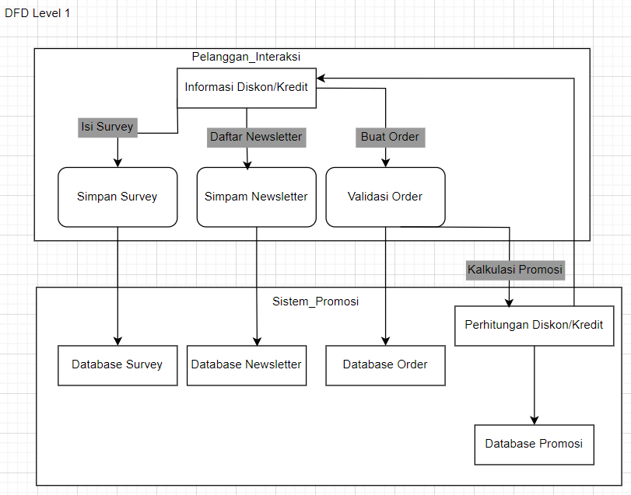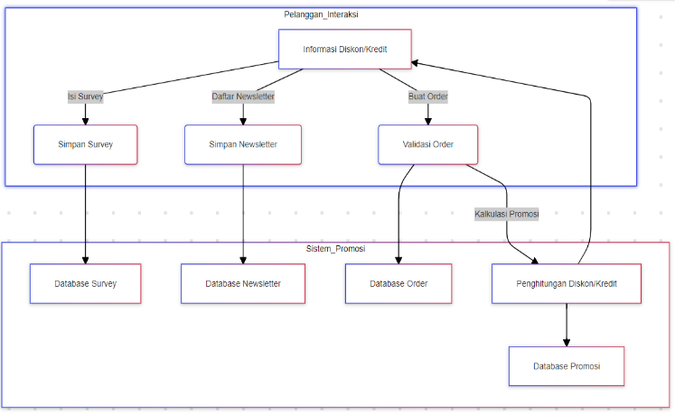 Mermaid Draw.io

1. Entity Relationship Diagram (ERD)

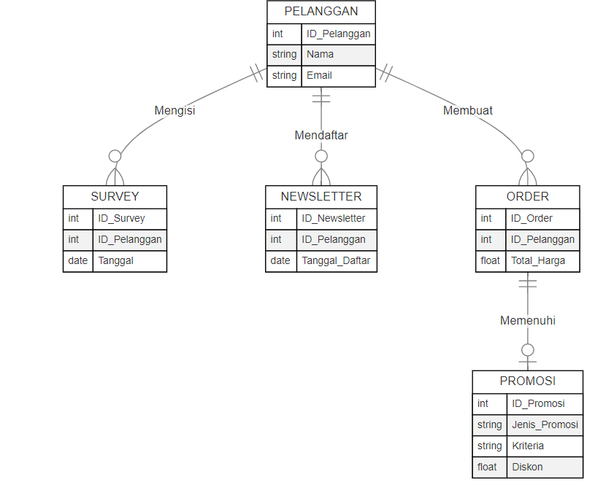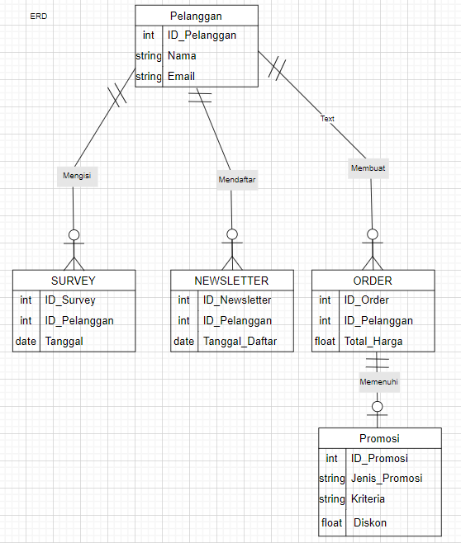Mermaid Draw.io

1. UML
2. Use Case Diagram

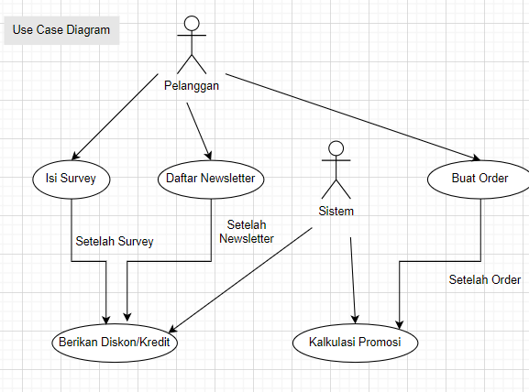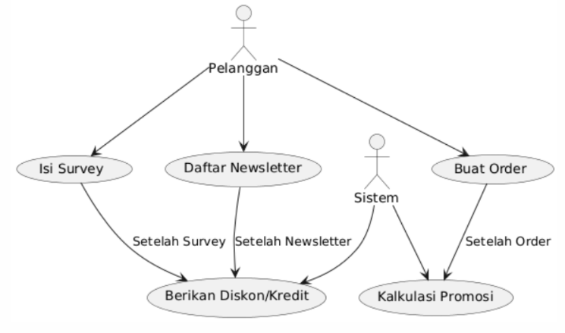 PlantUML Draw.io

1. Class Diagram

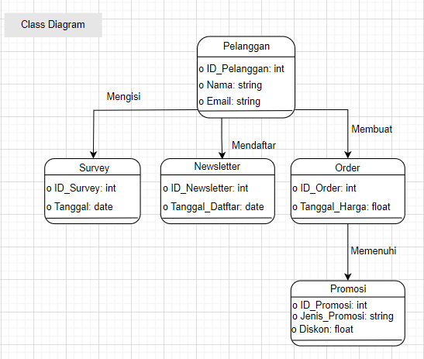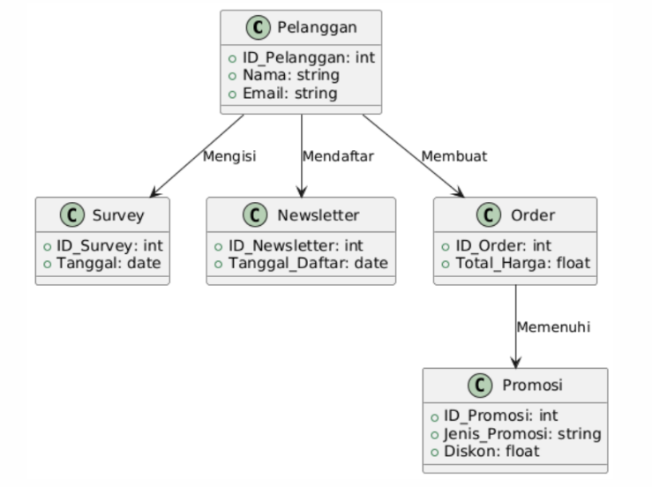PlantUML Draw.io

1. Sequence Diagram

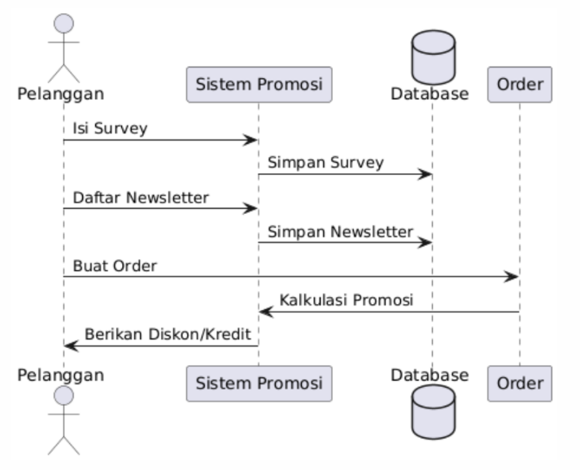 PlantUML Draw.io

